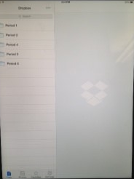

1. Make certain your project is titled with one name period # and date: Mckenzie 1 1861.
2. Once your project is finished and you saved a copy in iMovie, export your saved copy to the camera roll using the export icon.
Now you are ready to sign in to Dropbox with the information supplied by your teacher.

3. Select the folder that applies to your class.
4. Open the selections under the …

5. Select + Add files.

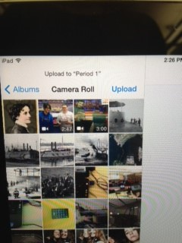

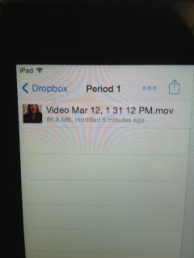

6. Open the Camera Roll and find your saved movie.

7. Select your movie and click UPLOAD.

8. You should always open your work before exiting to make certain the upload is complete. Log out of all accounts.

